Ad
Student’s Name
Institutional Affiliation

Covid-19 is a number one killer pandemic in the present world. Since our company wants to keep you and your family safe, we have developed a new magnificent product to combat the spread of covid-19.

Behold!!!!!!!!!!!!
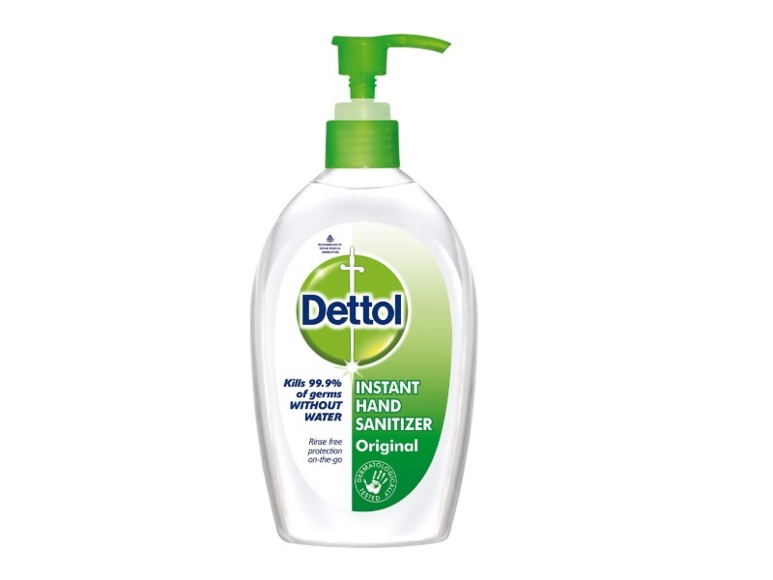
Consider yourself safe with Dettol Hand Sanitizer. The following are benefits of this product:
- Resists/kills coronavirus
- Killing germs instantly
- Refreshment
- No irritation
- Portable
Also, our hand sanitizer comes in all sizes that suit your taste and preference.
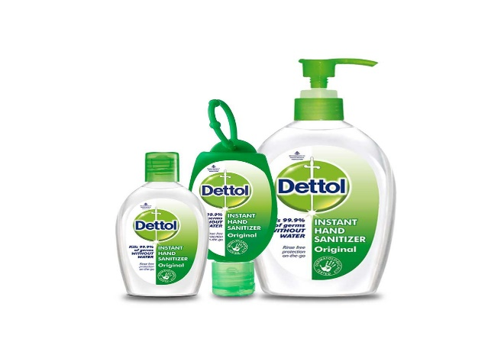
As a world-class company, we care about our esteemed customers’ health. Indeed, health is wealth!!!!!!!!!!!!!!!!!!!!
Let’s come together and fight this novel coronavirus.
Intended Audience
This ad targets a wider audience globally. Since health is a general issue in the world, this ad is targeting the general population, including children, young adults, adults, and the aging population. Therefore, this ad is all-inclusive since coronavirus is not selective; anyone can get infected easily.
Approach and Advertisement appeal
This advertisement utilizes emotional appeal. For instance, the ad is shaped to respond to consumers' needs and fears. It is apparent that people fear coronavirus. Therefore, this ad aims at attracting the audience to purchase and consume this product to avoid being infected with the coronavirus.
Also, this advertisement integrates a specific approach. The ad is informative in nature. The ad informs the audience on coronavirus and the respective benefits associated with this product. Therefore, the audience is likely to get informed as early as possible so that they can make the right decision of purchasing this product to keep themselves safe from Covid-19 disease.
Inspiration and Element of Social Responsibility
The main thing that inspired me to create this ad is the increase in the number of Covid-19 deaths and hospitalization as a result of the new delta variant. Also, most people resist covid-19 vaccinations.
This ad entails an element of social responsibility. For instance, the ad intends to benefit a diverse population. This ad aims at curbing the spread of coronavirus that has killed millions of people globally. Therefore, it shows some responsibilities because it cares for human life. It is also guaranteed that this product will benefit society as a whole.

